Angular JS

**Why Angularjs?**

If you are using JavaScript to create a dynamic website, angularjs is a good choice.

* Angular helps you to organize your JavaScript
* It help you to create responsive web stuff
* It play well with JQuery
* Easy to test

Few Features of angularjs

1. Its support two ways data-binding.  
     2. Its support MVC pattern.  
     3. Its support static template and angular template.  
     4. You can add custom directives.  
     5. Its support REST full services.  
     6. Its support form validations.  
     7. Its support both client and server communication.  
     8. Its support dependency injection.  
     9. Applying Animations.  
     10. Event Handlers

Key Features

1. Scope,
2. Controller,
3. Model,
4. View,
5. Services,
6. Data Binding,
7. Directives,
8. Filters,
9. Validation and
10. Testable

**Traditional Webpage refresh**

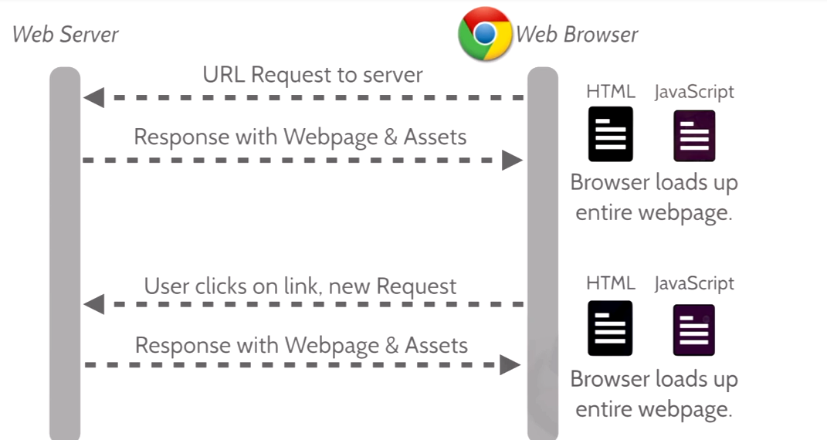

**Responsive website**

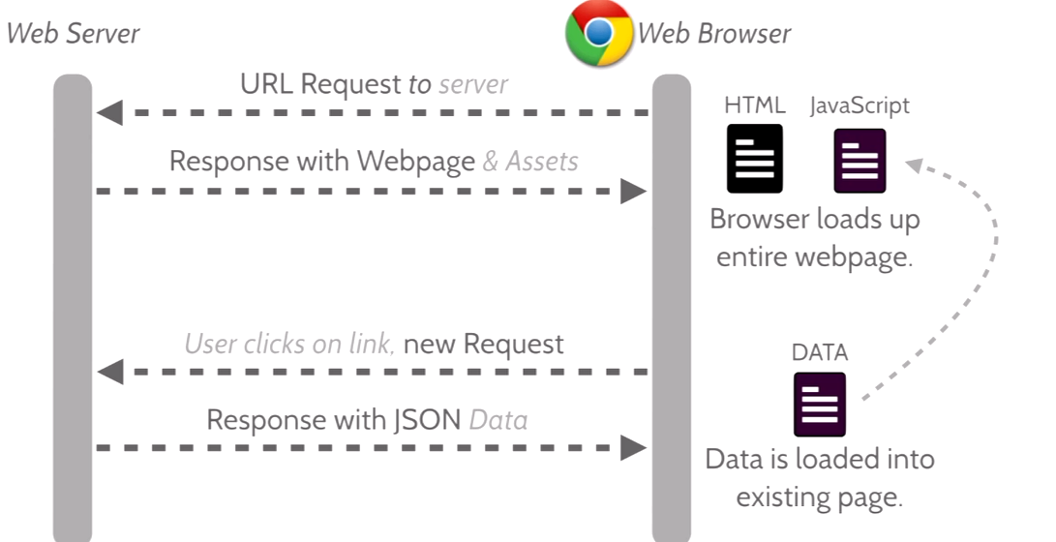

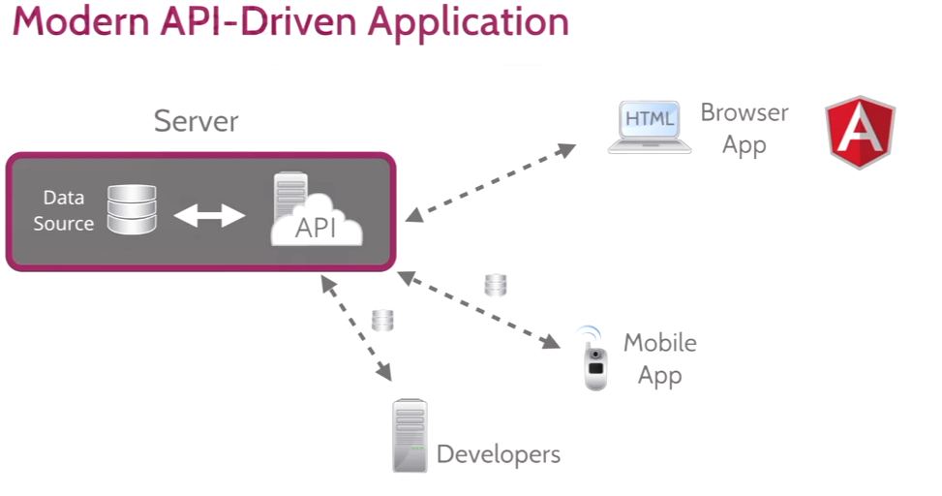

**What is angularjs?**

A client side javascript framework to adding interactivity to HTML. In html, we can add behavior to HTML through the Directives.

It help to design SPA (Single page application) .

A Directive is a marker on HTML tag that tells angular t run or reference some javascript code

**Modules**

Production-ready controllers by encapsulating our functionality in a single core unit called a module.

In Angular, a module is the main way to define an angularjs app. The module of an app is where

We’ll contain all of our application code. An app can contain several modules, each one containing

Code that pertains to specific functionality.

Using modules gives us a lot of advantages, such as:

* Keeping our global namespace clean
* Making tests easier to write and keeping them clean so as to more easily target isolated

Functionality.

* Making it easy to share code between applications
* Allowing our app to load different parts of the code in any order
* define dependencies for our app

The Angular module API allows us to declare a module using the **angular.module()** API method.

When declaring a module, we need to pass two parameters to the method.

The first is the name of the module we are creating.

The second is the list of dependencies, otherwise known as injectables.

Example:

angular.module('myApp', []);

// below is setter method.

angular.module('myApp', []);

// this method fetches the app means getter method.

angular.module('myApp');

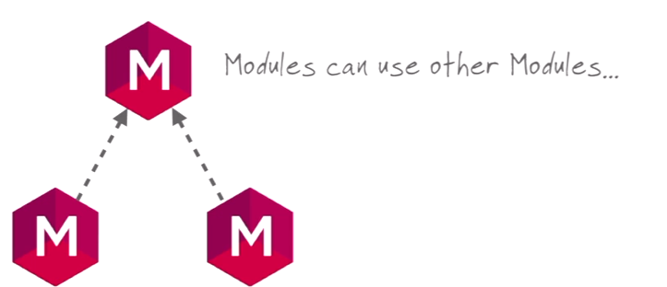

Creating first Module

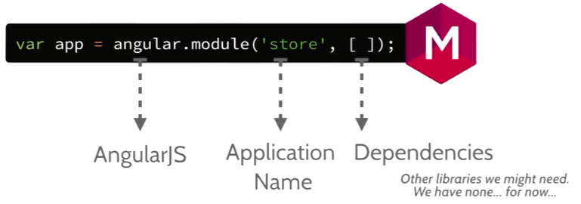

Include Our Module in to html page

app.js

var app = angular.module(‘vmc’,[]);

Index.html

<!DOCTYPE html>

<html ng-app="vmc">

<head>

<script src="Scripts/vendor/jquery-migrate-1.2.1.js"></script>

<script type="text/javascript" src="Scripts/vendor/angular.js"></script>

<script type="text/javascript" src="Scripts/app.js"></script>

</head>

<Body>

</Body>

</html>

ng-app=”vmc” 🡺 run this module when documents loads.

ng-app is main directives in angularJS that is useful for bootstrapping. Also you can play with expression after using ng-app. It allows you to insert dynamic values into your HTML.

**Controllers**

Controllers are the place, where we define our app’s behavior by defining functions and values.

Var userIfo = {

Name: ‘Brajesh’,

City: ‘Noida’,

Description: ‘Hi how are you’,

}

Controller declaration as below

UserController.js

Vmc.controller(‘UserController’, function(){

//your Logic goes here

});

Index.html

<body ng-controller=” UserController’”>

</body>